1. Soil C pool data was calculated from bulk density and C% (Table 1, page 1031)

The paper does not report carbon density directly. We calculated carbon density from Table 2, which reported percent organic carbon and bulk density, but not carbon pool.

Soil C pool (OCg_cc) = Bulk density * Organic C%

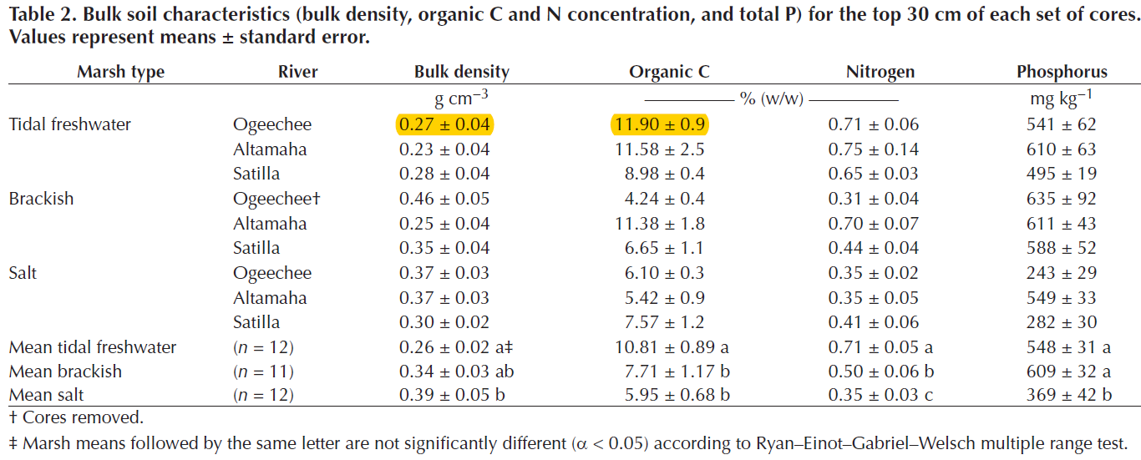

2. Soil C rate data was extracted from Fig. 4a on page 1032.

